

Sree Sainath Nagar, Tirupati – 517 102

**INDIAN SOCIETY FOR TECHNICAL EDUCATION (ISTE)**

**(MBU- STUDENTS CHAPTER)**

**Event Name: ISTE MBU & SVEC website Launch**

**Event Description:**

We are excited to share that our club achieved a major milestone by launching the official website of ISTE MBU & SVEC Club! This special event celebrated the hard work and creativity of our team and highlighted the club’s vision for growth and connectivity.

The website is designed to represent our club’s activities, achievements, and members. It provides an interactive space for everyone to learn more about the club and its events while also making our activities accessible to a wider audience.

**Welcome Speech**

* Event started with Devotional Song by Srikala.
* Then event continued with a warm welcome for our faculty, alumni, and students who joined us to celebrate this occasion.

**Website Walkthrough**

* A live demo of the website was given, showcasing its main features:
  + **About Page**: Tells the story of our club and its vision.
  + **Events Page**: Displays details of upcoming and past events with links to register.
  + **Our Team Page**: Introduces the faculty heads, coordinators, and members of our club.
  + **Gallery**: Features memorable photos from our club’s activities.
  + **Admin Login**: Allows the team to manage events and content easily.

**Closing Words**

* + The event ended with motivational words from our faculty, encouraging us to aim higher and take on new challenges.

**Tech Behind the Website**

* Website link**: istembu.in**
* Frontend: HTML, CSS, JavaScript, Bootstrap
* Backend: Node.js, Express.js, MongoDB
* Hosting: Hostinger

The website launch was a proud moment for all of us, showing what teamwork and dedication can achieve. This is just the beginning of many great things for ISTE MBU & SVEC Club!

**Date**: 19th October 2024  
**Time**: 9:30 AM to 1:00 PM  
**Venue**: Civil Seminar Hall, SVEC

**Event Poster:**

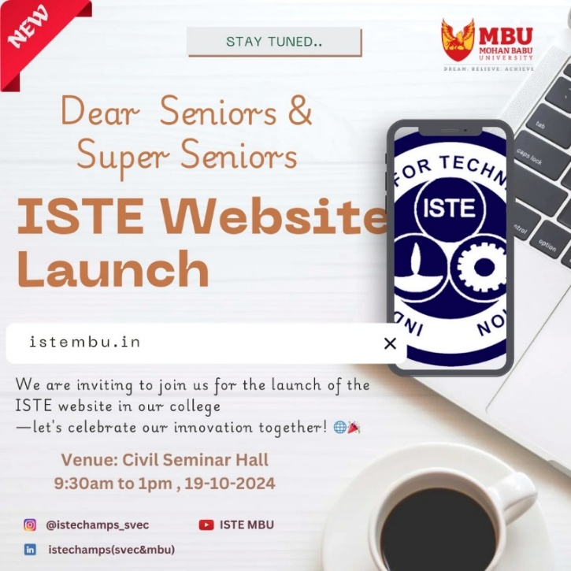

**Event Conducted By : ISTE MBU**

**Event Photos:**

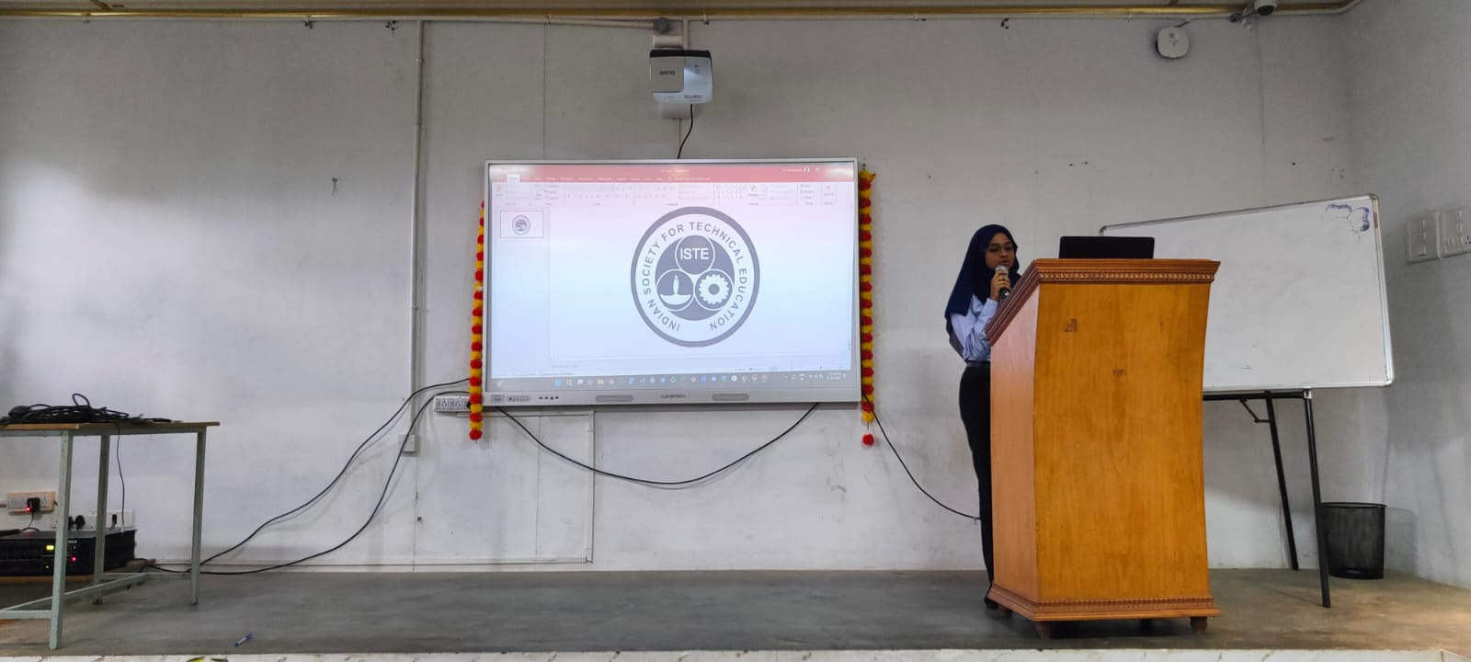

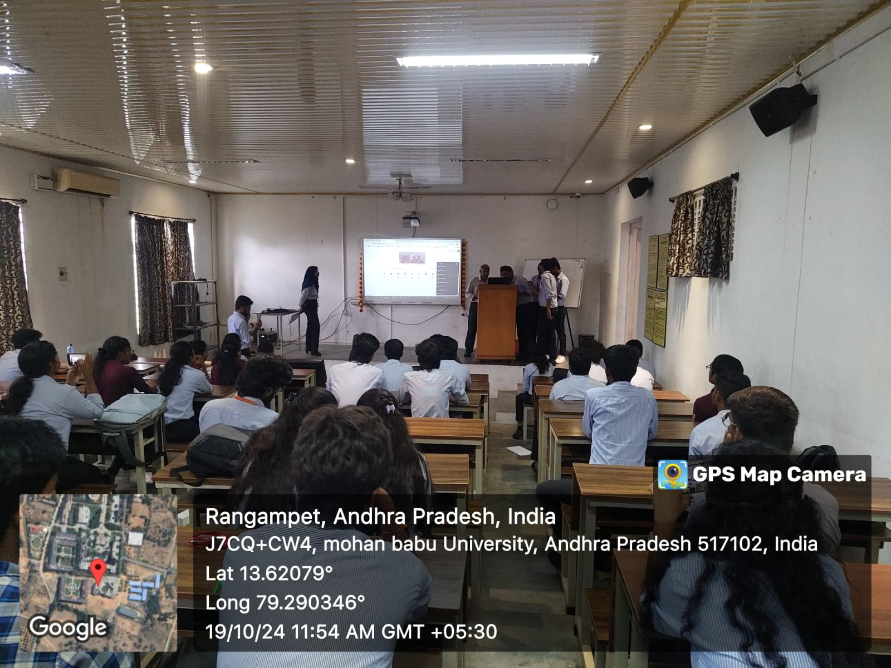

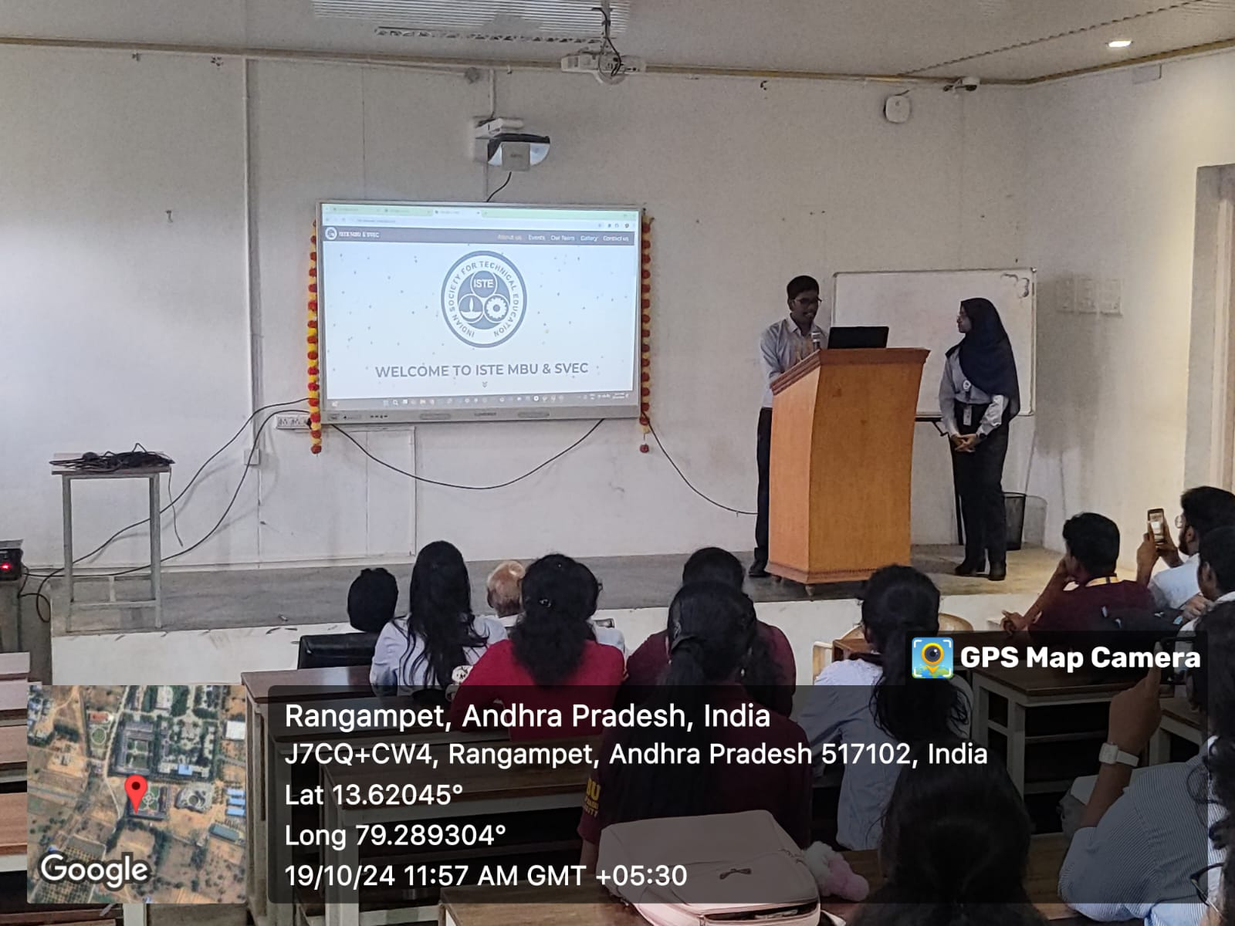

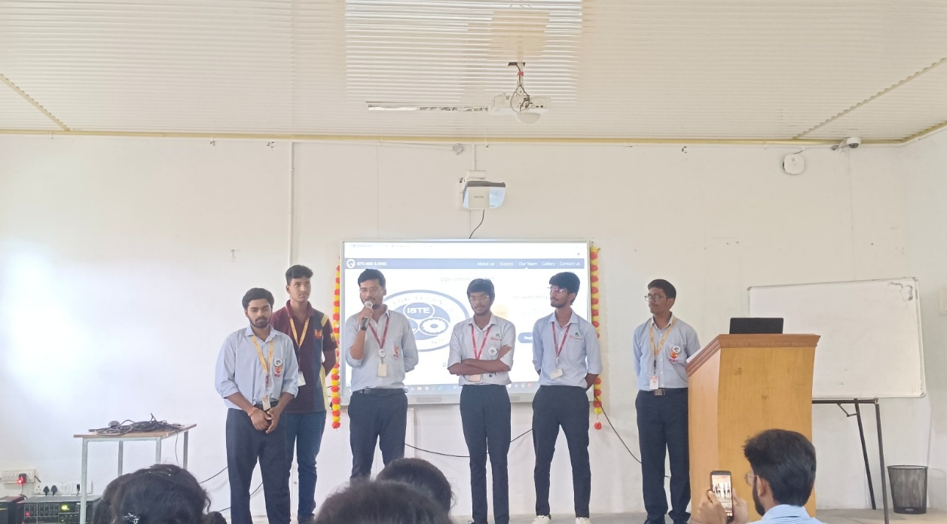

**Feedback Session**

* + Faculty and students shared their thoughts and loved the clean, user-friendly design of the website.

**Acknowledgement:**

We pledge our sincere thanks to our faculty advisor Dr. M. Sunil Kumar sir, chairperson Karthik and Secretary Annajappa, and all student coordinators for their contribution in making this event super successful.